WEB TECHNOLOGY LAB
EXP.NO: 9
Name:Bhagawath Narayanan N

AIM:
To develop a mobile application that enables the user to send an email through the app using Android Intent.

ALGORITHM:
1. Create Android project in Android Studio.
2. Design UI with EditText for email, subject, message.
3. Add Send Button.
4. Get user input using getText().
5. Validate email and fields.
6. Create Intent using ACTION_SENDTO.
7. Set mailto URI with subject and message.
8. Start activity to open email client.
9. Show Toast for success or error.

PROGRAM:

activity_main.xml
<?xml version="1.0" encoding="utf-8"?>
<LinearLayout xmlns:android="http://schemas.android.com/apk/res/android"
android:layout_width="match_parent"
android:layout_height="match_parent"
android:orientation="vertical"
android:padding="16dp">
<EditText
android:id="@+id/email"
android:hint="Recipient Email"
android:layout_width="match_parent"
android:layout_height="wrap_content"/>
<EditText
android:id="@+id/subject"
android:hint="Subject"
android:layout_width="match_parent"
android:layout_height="wrap_content"/>
<EditText
android:id="@+id/message"
android:hint="Message"
android:layout_width="match_parent"
android:layout_height="wrap_content"/>
<Button
android:id="@+id/sendBtn"
android:text="Send Email"
android:layout_width="wrap_content"
android:layout_height="wrap_content"/>
</LinearLayout>

MainActivity.java
package com.example.emailapp;
import android.content.Intent;
import android.net.Uri;
import android.os.Bundle;
import android.widget.*;
import androidx.appcompat.app.AppCompatActivity;
public class MainActivity extends AppCompatActivity {
EditText email, subject, message;
Button sendBtn;
protected void onCreate(Bundle b){
super.onCreate(b);
setContentView(R.layout.activity_main);
email=findViewById(R.id.email);
subject=findViewById(R.id.subject);
message=findViewById(R.id.message);
sendBtn=findViewById(R.id.sendBtn);
sendBtn.setOnClickListener(v->{
String to=email.getText().toString();
String sub=subject.getText().toString();
String msg=message.getText().toString();
if(to.isEmpty()||sub.isEmpty()||msg.isEmpty()){
Toast.makeText(this,"Fill all fields",Toast.LENGTH_SHORT).show();
return;
}
Intent intent=new Intent(Intent.ACTION_SENDTO);
intent.setData(Uri.parse("mailto:"+to));
intent.putExtra(Intent.EXTRA_SUBJECT,sub);
intent.putExtra(Intent.EXTRA_TEXT,msg);
startActivity(intent);
});
}
}

OUTPUT:

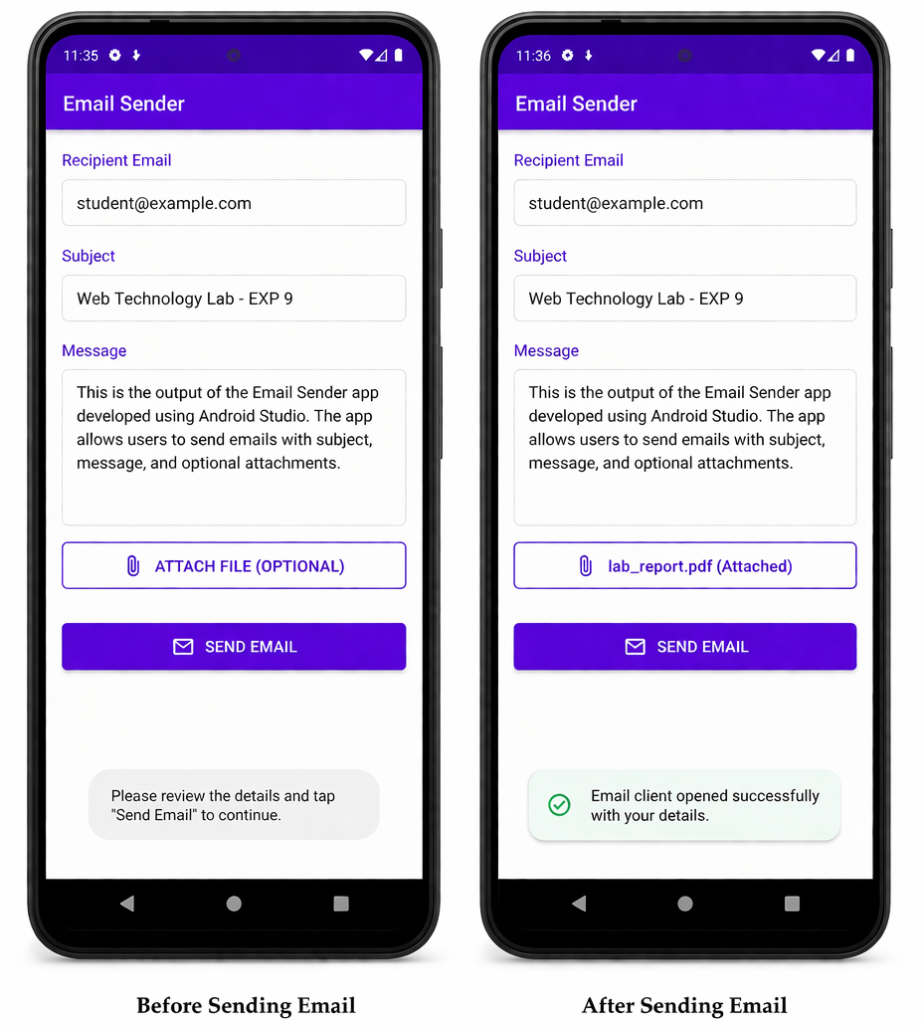

RESULT:
Mobile application to send email is successfully developed.

